In the coming years, the Faculty will make an extra investment in two research themes: 'Digital legal studies: building technology for law' and 'Law in a globalizing society: regulation and protection.’ The assistant-professor is expected to do research on one of these two themes.

The ‘Digital Legal Studies’ Experience
The Digital Legal Studies research takes on the ambition to develop a research infrastructure that allows applying artificial intelligence to analyze case law in order to answer legal research questions and to solve legal problems (academic and societal). You will be offered the opportunity to learn and apply data science methods and solutions in relation to the legal domain. The research takes place within the Maastricht Law & Tech Lab, a fun and vibrant community where legal scholars and data scientists meet and form interdisciplinary teams that work at the intersection of Law and Data Science. Colleagues describe the community as diverse yet inclusive, ambitious, and cutting-edge, and where initiative is fostered and personal development encouraged.
About the Research
Law and technology research can be divided into Law for Technology research (e.g. privacy, liability for self-driving cars, legal status of blockchain) and Technology for Law research. The Digital Legal Studies research within the Maastricht Law & Tech Lab focuses on the latter. It aims to apply Data Science methods to the legal domain in order to unravel the “Legal DNA” of case law. More specifically, it aims to:
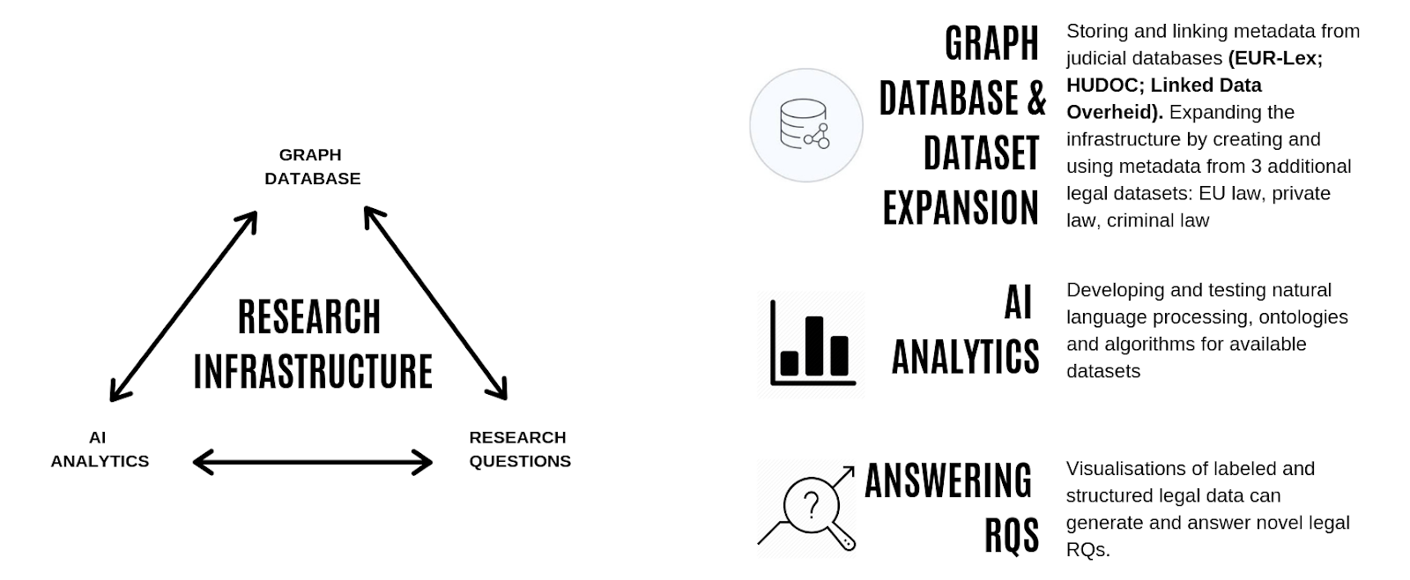

- Create a database (focusing on publically available judicial/legislative datasets)
- Test and develop analytical tools (artificial intelligence)
- Answer cutting edge (empirical) legal research questions.

Law in a globalizing society: regulation and protection
The overarching question of this research plan is what role law has in a globalizing society, and, in particular, how globalization is challenging the potential of the law to regulate, protect and solve disputes. The process of globalization brings about a number of challenges in the legitimacy of decision-making processes, which are linked to 1) the level of governance involved in policy-making and the implementation of norms at local, regional and international level; 2) the type of instruments of regulation which is being used; and 3) in the type of actors involved in regulation.
With complexity in the level of governance, one should understand phenomena such as the phenomenon of global standards entering the EU legal systems, the Free Trade Agreements concluded between the EU and several third countries, international treaties on tackling and preventing crime, the various mechanisms of cooperation between EU authorities and national authorities in the implementation of EU law, or the regulation of internet governance and data flows. Often, this form of complexity comes with a varying degree of transnationality, ie the capacity of a norm to be applied and/or enforced outside the territory of the authority which issued it.
Complexity in the form of instruments can be seen both from the perspective of regulatory mechanisms which depart from traditional ‘command-and-control’ forms of governance towards ‘soft’ governance and market-based instruments, and from that of the progressive increase of regulatory setups combining different fields of law (private, administrative and criminal law) to achieve (global) policy goals, such as fair market competition, security or crime and harm prevention.
Complexity in the type of actors refers to mechanisms whereby regulatory tasks are (partially) delegated to third parties, as is the case with technical standards, civil and criminal justice functions, tasks linked harm reduction, risk management as well as harm and risk prevention, as well as code of conducts and other self-regulation mechanisms (such as certification).
The aim of the plan is to examine how, in a globalizing society, a sufficient degree of legitimacy of decision-making, of protection and effective conflict resolution can be ensured.
This overarching aim is operationalized through two main research questions:
- How, given the complexities in governance levels, instruments and actors, to ensure a sufficient degree of legitimacy in regulation?

The research conducted to answer this research question will tackle the possible need to re-think the traditional notion of legitimacy, and thereby, the corresponding justifications for state intervention due to the need to tackle (global) risks. Under this first research, relevant issues to be tackled are, for, example, what procedural guarantees should soft law-making respect or to which requirements and conditions should private parties adhere when they exercise public functions, e.g. in terms of transparency and representativeness, but also how different legal principles are able tackle the challenges of globalization and how the action of private actors can be best controlled.

- How, given the complexities in governance levels, instruments and actors, to ensure a sufficient degree of judicial protection and conflict resolution?

The research carried out under this research question will lead to a discussion of the possible need to re-think the division of competences between EU and national courts, and between national courts themselves as well as of the forms of control which the courts are able and should exercise to control the actions of private parties when they exercise public functions. For example, relevant sub-questions are how private parties get into the reach of law when they operate globally, how can checks and balances be imposed on private actors and agencies that carry out and/or coordinate crime control and risk management functions, what role is there for European and national fundamental rights, or the extent to which codes of conduct and self-regulation mechanisms can be considered enforceable.
Furthermore, under this research question, a relevant question is how courts deal and ought to deal with increasingly (technically and scientifically) complex decisions. In this context, sub-questions may be, amongst others, what the role of science in court is, whether courts have sufficient access to expert knowledge, what the correct standard of review in these cases is, and whether differences in this context impair the principle of effective judicial protection and uniform application of EU law.
Traditionally, law can be seen as having both a regulatory and a protection function. Ultimately, the two research questions answer the overarching question of (whether and) how globalization and its several complexities are changing the functions of law and in what way different actors can and should address these changes, also in light of the need to protect the weaker parties affected by globalization. Therefore, de lege ferenda, the research aims at re-thinking the potential for regulation, protection, and conflict resolution of the law.

